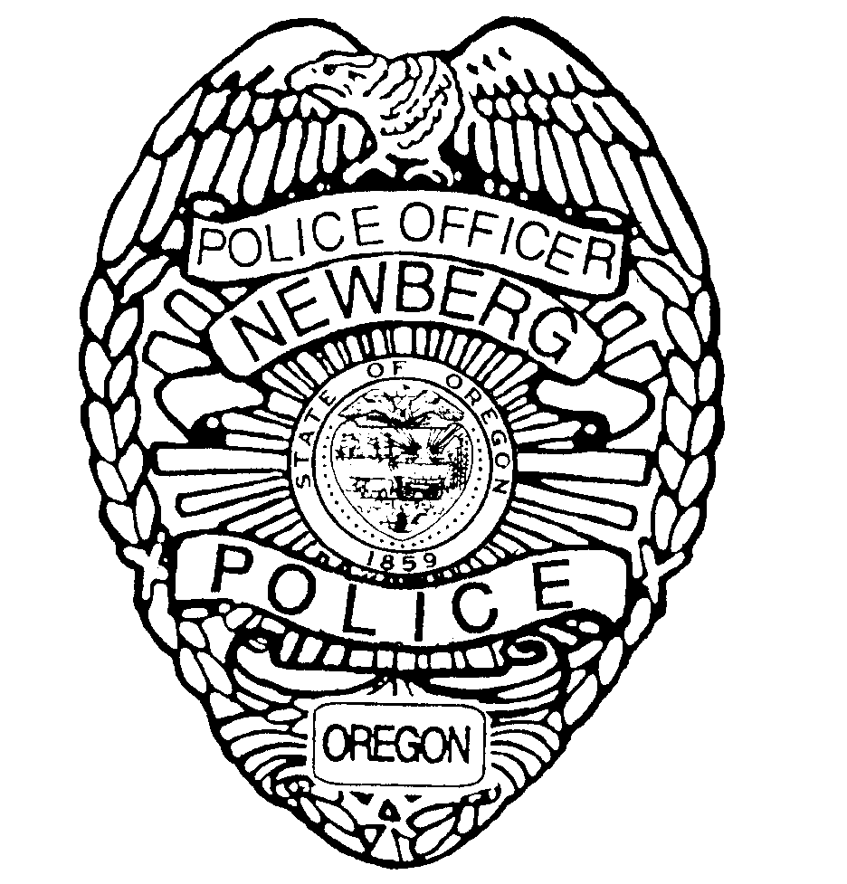
Newberg-Dundee
Police Department
P. O. Box 970
401 E. Third Street
Newberg, OR 97132
503-538-8321
Brian T. Casey
Chief of Police

The Newberg-Dundee Police Department is currently recruiting for the position of:

Reserve Police Officer

This is a non-paid, volunteer position which augments regular Officers of the department in the protection of life and property and assists in providing the community with the services of law enforcement, i.e., problem solving, public education and public safety response.

The Newberg-Dundee Police Department has a service population of approximately 26,000. The Officers of this department are responsible for the thorough and ethical enforcement of the City ordinances of Newberg and Dundee, the statutes of the State of Oregon and to uphold the United States Constitution.

Minimum Qualifications:

- High school diploma or equivalent
- Minimum age of 21 years at time of appointment
- Ability to read and write the English language, preference given for Bilingual ability.
- Absent of felony conviction
- Quick response for emergency call-in: residence within a 25-mile radius of Newberg or Dundee
- Possession of, or be able to obtain by time of appointment, a valid Oregon driver’s license
- Ability to provide documentation of United States citizenship by time of appointment
- Ability to participate in a comprehensive Reserve Training Program which will include commitment of two evenings/week and some Saturday instruction over a six month period
- Ability to meet Department of Public Safety and Standards (DPSST) physical (including vision and hearing) standards

Closing Date: March 15, 2016 / 5:00 pm

Testing Date: To be determined.

Candidates must pass:

- DPSST certified written test with a 75% or higher score
- DPSST certified Oregon Physical Agility Test (ORPAT)
- Oral board interview(s), extensive background check which includes criminal history, credit check, and fingerprinting and the requirement to submit to drug screening
- Psychological examination
- Pre-placement DPSST medical exam

Applications packets are available at the Newberg Public Safety Building
401 E. Third Street, Newberg, OR. 97132

Or

An online application packet can be downloaded from the City’s Website at: https://www.newbergoregon.gov/jobs

Return the completed application and any supplemental documents to: Newberg-Dundee Police Department, PO Box 970, Public Safety Building, 401 E. Third Street, Newberg, OR. 97132. Please include your email address on your application as this is our preferred method of contact. Resumes’ may be included, but will not be accepted in lieu of a completed City of Newberg application. Questions may be directed to 503-537-1227.

This employment opportunity is open to all persons without regard to race, color, religion, national origin, age, sex, marital status, political affiliation, veteran’s status, physical or mental disability, sexual orientation, gender identity or any other status protected by federal, state or local laws.

