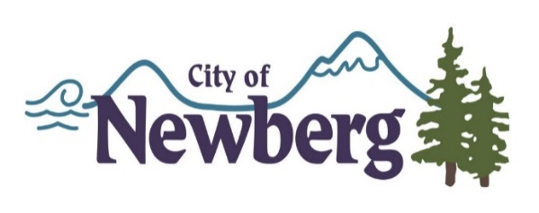

City of Newberg 2017 - 2018
Transient Lodging Tax – Small Grant Program Application

THE FOLLOWING ITEMS MUST BE INCLUDED WITH YOUR APPLICATION:
- Completed application Cover Sheet.
- Budget for project/program/event being funded that lists all anticipated income and expenses.
- Board or Owner approved financial statement for most recently completed fiscal year of the organization or business responsible for the project/program/event.
- Letter signed by officers of the Organization’s Board of Directors or Business Owners authorizing this application.
- Documentation of organization or business existence: Current, valid Oregon Secretary of State Corporation Division registry filing.
- Documentation that no bankruptcy or other financial corruption has occurred within the past five years.
- Letters of support.

Project Title: ______________________________________________________________

Applicant Name: ___________________________________________________________

Mailing Address: ___________________________________________________________
Street City State Zip

Contact Name: ____________________________________________________________

Phone: ____________________ Email: __________________________

Alternate Phone: __________________________

Website Address: __________________________________________________________

Secretary of State Business Registry Number: ____________________________________

Non Profit _________ Government ____________ For-Profit ____________

Amount of total Funding Requested: $___________________________________________

Please note: Funds not spent on the approved project, program or event must be returned to the City of Newberg by check with the Final Report due 30 days after completion of the project, program or event.

Classify how funds will be used for your project/program/event: check all that apply

_____ New Project _____ New Program _____ New Event

_____ Existing Project _____ Existing Program _____ Existing Event

Has this project, program or event received these grant funds in the past?

If so when and for how much?

Prior year grant award through this program does not guarantee additional funding in subsequent years. All returning projects, programs or events must reapply and are subject to approval. This program has limitations of funding available in the fiscal year in total amount of funds requested. All required reports must be in good standing at the time of application for future funding by a past grant recipient.
Budget Summary (this format must be used):

Project/Program/Event Budget: This budget provides the detail of the project, program or event that the grants funds would be applied to. This should include how the funds from this grant will be spent. Expenses must be explicitly defined. Please include in-kind and cash match.

Fiscal Year: _________ to ________

Income Sources | Amount
Total Project/Program/Event Income

Expenses – Must be explicitly defined. | Amount
Total Project/Program/Event Expense

Organization Budget: This budget shows how this project, program or event fits into your organization. Your project, program or event should be shown as a line in this budget.

Fiscal Year: _________ to ________

Income Sources | Amount
Total Organization Income

Expenses
Total Organization Expense

Project Narrative:

- Project description:

- How will your project, program or event further the Newberg Strategic Tourism Plan goals?

- How does your project, program or event align with Transient Lodging Tax regulations (Tourist, Tourism Promotion, Tourism Promotion Agency, or Tourism related facility)?

- What is the projected return on investment?

- Predicted number of tourists’ attracted/overnight guests?

- Will it have lasting impact and/or utility?

- How does your project, program or event leverage funding?

8. What is the ratio at which Transient Lodging Tax funds will be matched?

9. What is your demonstrated history of attracting tourists?

10. Does your project, program or event engage and energize local tourism partner(s)?

11. Does your project, program or event enhance Newberg as a destination? If so how?

12. Does your project, program or event enhance Newberg as a location for Makers and Doers? If so how?

13. Does your project, program or event catalyze downtown development? If so how?

14. Does your project, program or event enhance tourism from October – May or Sunday – Thursday Visitation? Explain how.

15. Does this project align with at least one of the four target audiences (Wine Country Adventurers, Millennial Explorers, George Fox Network, or Luxury Wine Travelers)?

16. What is the timeframe for completion of your project, program or event?

Signature and Certification Letter:

I hereby certify that all facts, figures and representations made in this application, including all attachments, are true and correct. This application is made with the written approval of my Board of Directors or Owners, which is attached to this application.

I agree that all publicity, press releases, publications, materials and or media advertising produced as part of this proposed project/program/event will acknowledge the grant program as follows:

“This project/program/event is made possible in part by a grant from Newberg transient lodging taxes and the City of Newberg.”

A agree to carry out this project/program/event as outlined within the application. Further, I understand that failure to do so will invalidate this agreement and necessitate the immediate return of all Transient Lodging Tax grant monies to the City of Newberg.

_________________________________________________ _________________
Signature of Authorizing Official Date

Print Name of Authorizing Official

