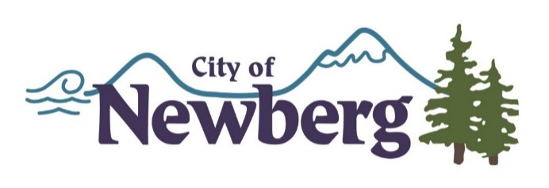

City of Newberg 2017 - 2018
Transient Lodging Tax – Small Grant Program Application Cover Page

Project Title: ___________________________________________________________

Applicant Name: ________________________________________________________

Mailing Address: ________________________________________________________
Street City State Zip

Contact Name: _________________________________________________________

Phone: ____________________ Email: __________________________

Alternate Phone: ____________________________

Amount of total Funding Requested: $_______________________________________

Please note: Funds not spent on the approved project must be returned to the City of Newberg by check with the Final Report due 30 days after completion of the project, program or event.

Project, Program or Event Detail:

- To apply, attach a completed application to this cover sheet along with any required supporting materials.
- Submit an updated Project, Program or Event Detail as your Progress Report.
- Within 30 days after project, program or event is complete submit a Final Report. Attach receipts/paid invoices for monies spent and a check to the City of Newberg for any unspent funds.

Any changes to your project must have prior approval to receive funding.

I agree to all terms described on this application and verify that the information provided on this cover sheet is true and accurate.

Print Name: ________________________ Signature: __________________

Title: ______________________________ Date: ______________________

******************************FOR OFFICE USE ONLY*************************************
APPROVED/NOT APPROVED/REVISED (ATTACH DETAILS) _____________________________________

Progress Report Received: ____________________ Final Report received: ____________________

Funds returned, received on: _________________

